India tour 14-30 November 2018
Udaipur in semi Desert
Friday 23rd November 2018
Day 10:- Udaipur day 2.
No wakeup call this morning being the 2nd day in the Trident hotel in Udaipur. Alan was up at 6.30am, ready for breakfast at 7.20am which was again a buffet style with about 12 waiters running around helping with one’s selections from a vast number of dishes and fruits on offer.
The bus for the day’s tour activities was scheduled to leave at 9.15am but just as all were settled on the bus the group was asked get off and assemble in the hotel lobby. Here an announcement was made that a change in hotel was made by the tour operator and there was 20 minutes to pack cases and have them outside room door ready to be collected by the hotel staff and transported to the new hotel. This is the Oberon hotel on the edge of Lake Pichola. Classified as a 7 star rated hotel. Oh well, Alan had to stuff his still moist laundry from the night before into a plastic bag to not dampen other clothes in his case. Then to settle any outstanding charges at the Trident before boarding the bus again. Phew! This hotel normally charges guests $A900 per night so the tour company must have made a special deal for us.
First stop the city palace where the local King still resides with his family in a closed off (well-guarded) section of the building complex. There was a long walk up a steep ramp and several steps to negotiate at the entrance to the tourist section of the palace. Many icons inspected by the group. Ancient ivory door, coloured glass chambers and mirrors galore. A great view from the top floor of the surrounding city and Lake Pichola with a white marble exclusive hotel in the middle.

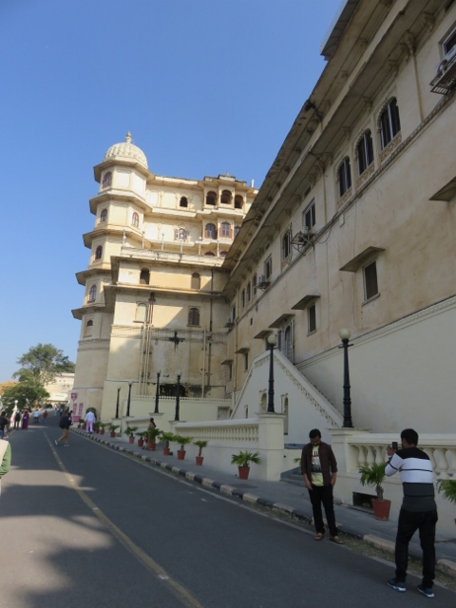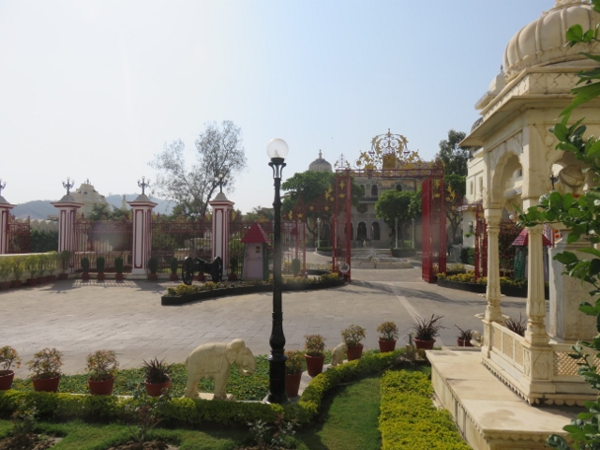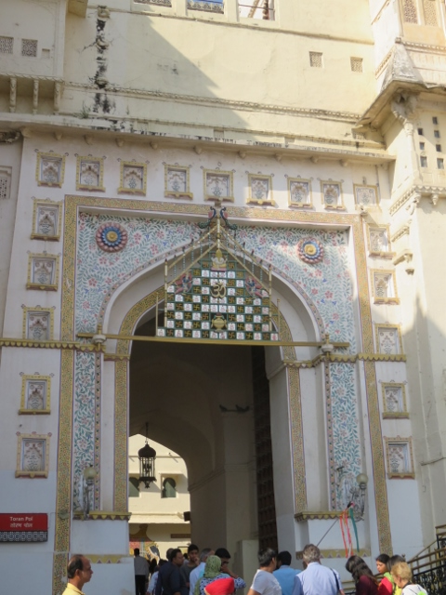
Ramp up to Udaipur City palace at top of ramp, Kings Residence Marble gate with ivory doors.

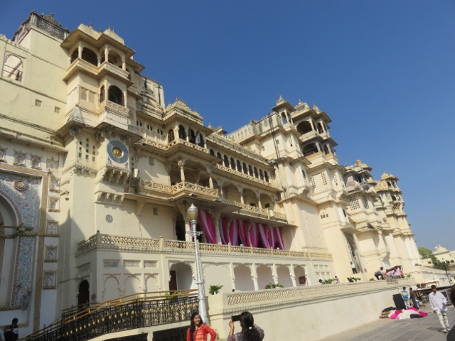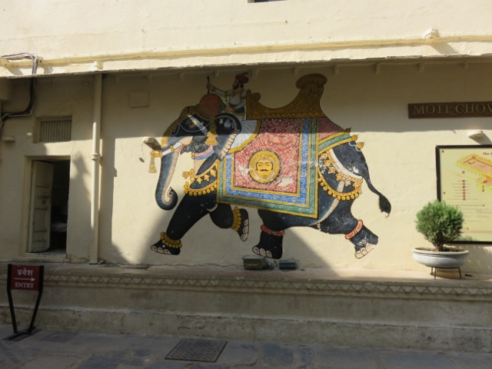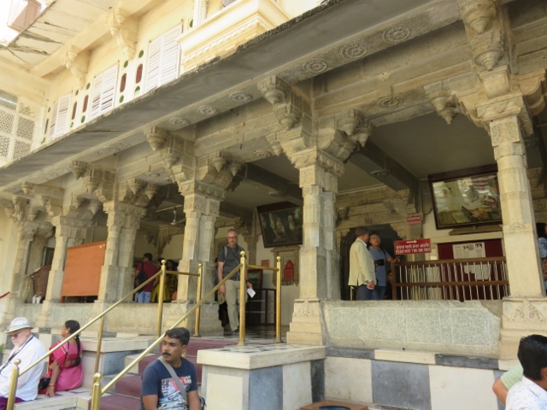
Palace outside wall & balconies Elephant mural on wall inside entrance to palace rooms
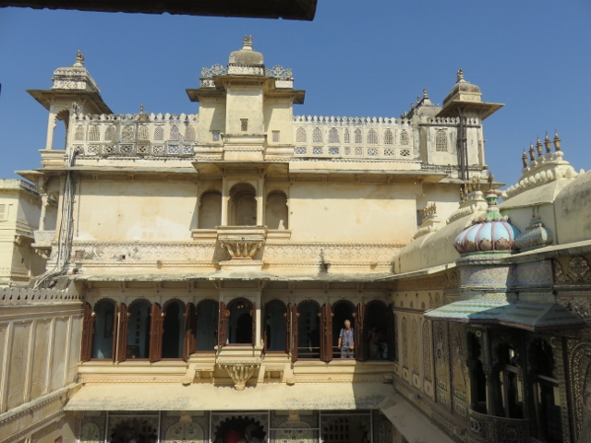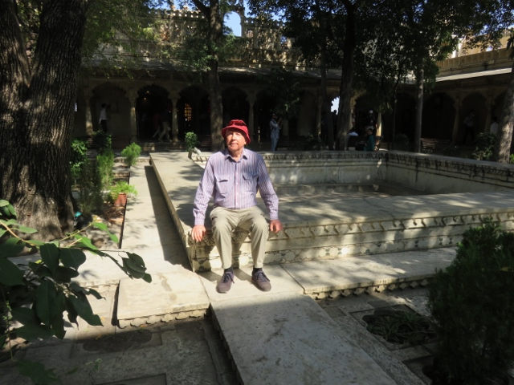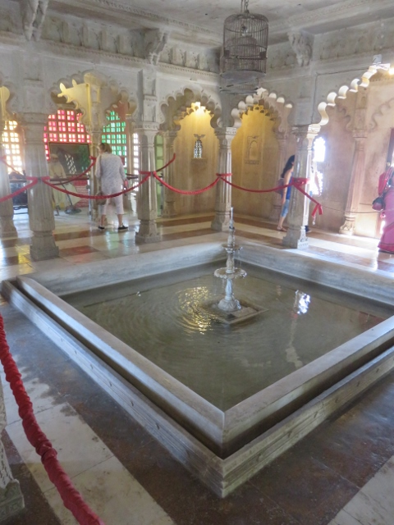
Top of palace and speech dais Alan resting at inner marble courtyard Interior fountain to keep cool.
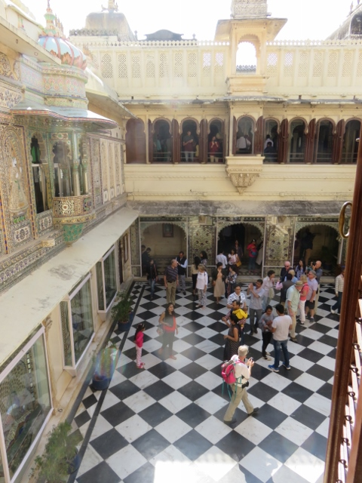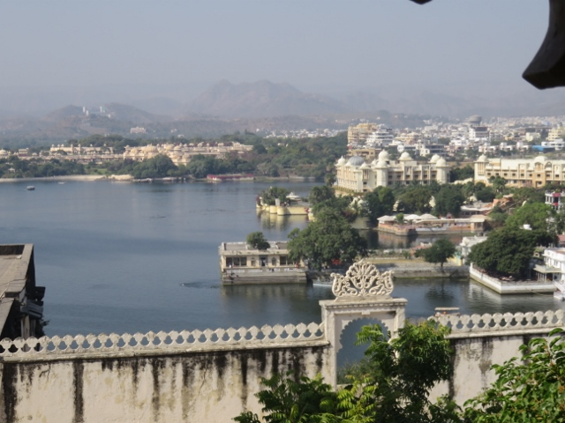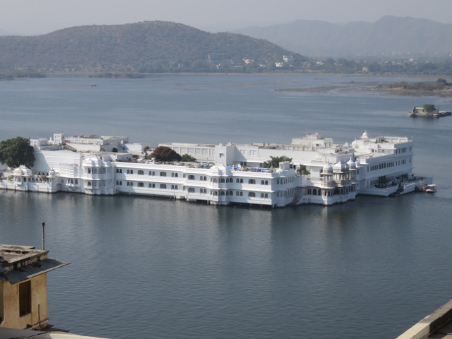
Black & white tiles in courtyard View of hotels from top of Palace Marble hotel on island Lake Pichola.
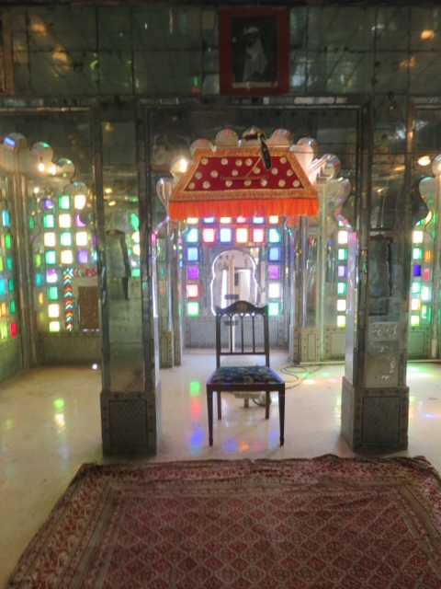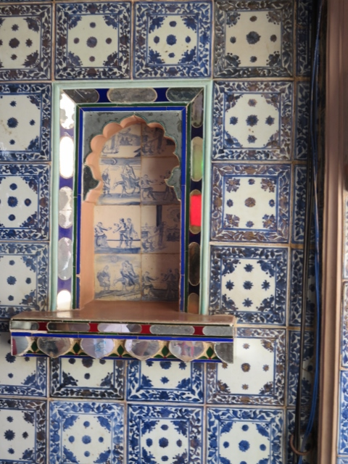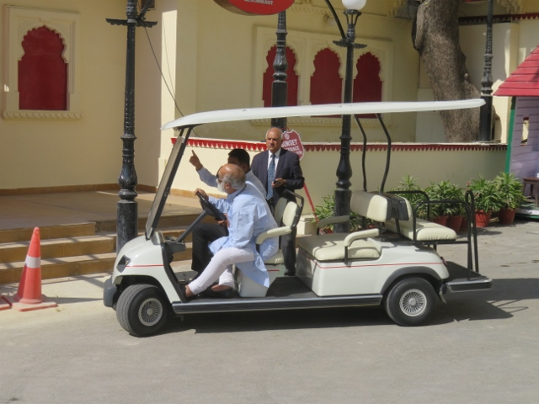
Coloured glass meeting room special picture tiles set in wall King driving golf cart down ramp.
Back down the rampart to reboard the bus which then delivered the group to a city restaurant. On the way down the rampart a golf buggy type vehicle drove past the crowd and Harch, our tour guide, pointed out that the slightly balding grey hair driver was indeed the King himself. Harch should know as Udaipur is his home city where he lives with his wife and 2 small boys.
The Oberon hotel is very swish for a 7 star rating. Black and white marble flooring throughout every floor and turbaned hotel staff in colourful uniforms to guide guests to their allocated room and provide 24 hour butler service as needed. Alan was taken to room 310 only to have the staff man interrupted in his spiel about the room and its facilities to be told that a mistake had been made and that room was occupied by another guest. Alan was then taken to room 223 which was very similar to the previous room. The room is very large with a bay window overlooking a private courtyard which in turn gives access to a grassed central court with a 25 metre swimming pool in the centre.
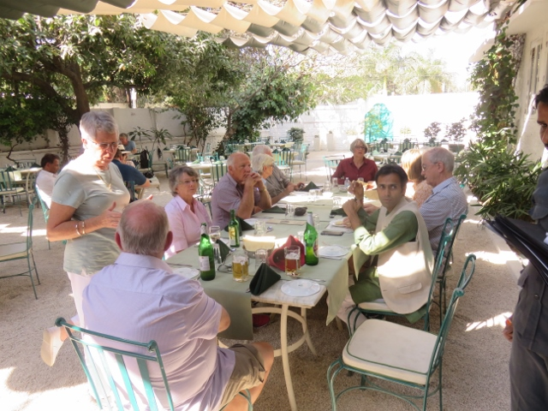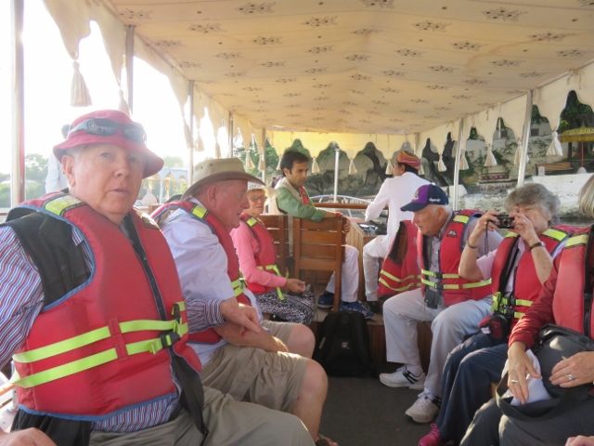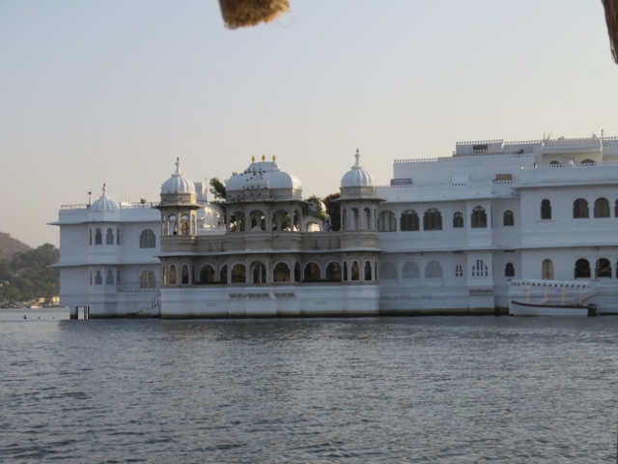
Lunch venue under canopy Alan on boat for lake cruise up close with marble hotel in lake.
At 4pm the tour group assembled in the hotel lobby for the next event which was a drive in an electric golf cart vehicle down to the edge of Lake Pichola. Here at a small wharf there was an open flat bottom tourist boat waiting to take the group on board for a trip around the lake. Donning life jackets was mandatory. Beautiful scenery awaited the cruise around the lake in the late afternoon light.
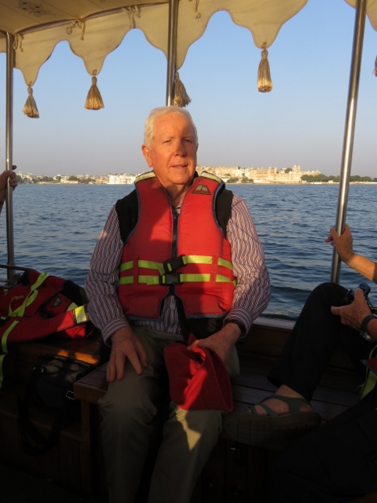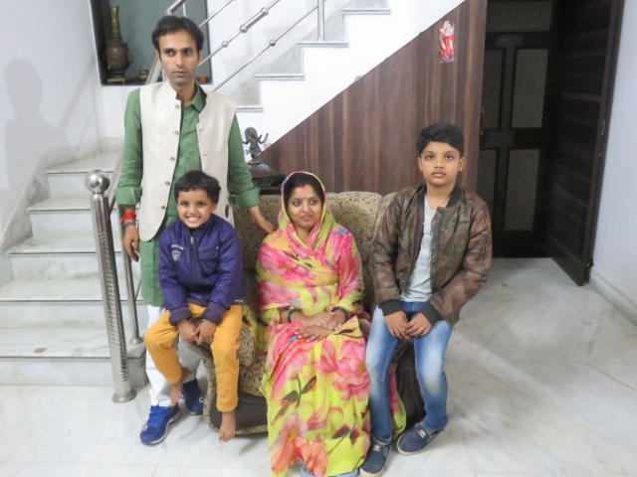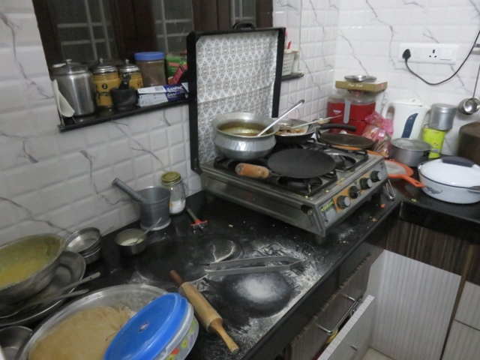
Alan with marble hotel in background Harch and wife +- 2 boys Harch family kitchen.
Returning to the wharf and a short walk back up a slight rise to the hotel, the group arrived at 5.20pm and had to re-
assemble in the lobby at 5.50pm for a bus drive to the night’s dinner venue. This turned out to be the Indian tour
guide, Harch, family home where his wife and sister had prepared a typical Indian middle class dining experience for
these Ozzies. This was a good example of a family home in Udaipur and the type of food consumed. Several dishes
provided as the group settled around 2 large circular tables. One on the deck of the 2nd story and one on the dining
room inside. Harch pointed out the “hot” dishes and samples of each one an interesting experience.

Back to the hotel by 9.30pm and into bed by10.00pm.

Some more photos of the Jain Temple visited on route to Udaipur on day 9:-
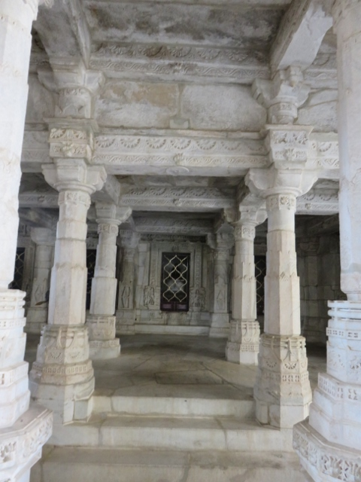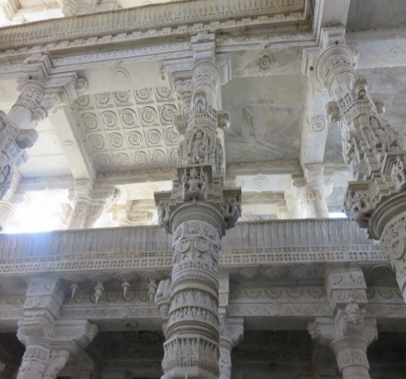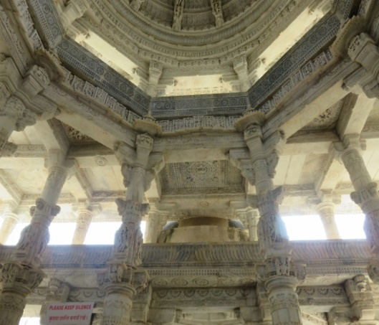
Marble pillars everywhere many decoratively carved Open light wells to illuminate interior.

